WEB DEVELOPMENT COURSES (WBC) PROJECT

Software Requirements Specification

|  |  |  |  |
| --- | --- | --- | --- |
|  | Prepared By | Reviewed By | Approved By |
| Name | The Dream makers | Devathilagai |  |
| Role | Interns | Batch Trainer |  |

**Table of Contents**

Table of Contents…………………………………………………………..….......II

1. Introduction…………………………………………………………………..…1

1.1 Intended Audience……………………………………………….......1

1.2 Project Scope…………………………...……………………………1

2. Overall Description…………………………………………….……………….1

2.1 Operating Environment……………………...……………………....1

3. Requirements……………………………………………………………...…….1

3.1Login………………………………………………………………….2

3.1.1Description………………………………………………....2

3.1.2 Functional Requirements……..…………………………...2

**1. Introduction**

Coursera is an online learning website. We are taking and testing one functionality of that website (i.e.) Searching for Web Development courses. and also extract the look for the language learning

**1.1 Intended Audience**

Business Unit (BU) SME

Academy coach

Technical Trainer

**1.2 Project Scope**

This document defines at a functional level the business activities that are encompassed by the system and the rules that apply to them. It also encompasses some of the key high and low level technical requirements of the system.

It draws heavily on both proposed Framework and Business Rules and the Technical Architecture documents. The scope of the detailed analysis project phase specifies that this document will include.

· Classification of requirements according to their functional areas.

· A description of each process in the system, including their inputs, outputs, and data transformation rules.

**2. Overall Description**

**2.1 Operating Environment**

Windows operating system

Web application

**3. Requirements**

This part of the requirements document serves to present the "Coursera for web development courses" of the application and also we need to extract all the levels in “Language Learning”.

**3.1.1 Functional Requirements**

**3.1.1.1 Req0001**

**Req0001a-**The user enters the text as “Web” in search box and selects “Web Development” from the auto suggestion list box.

**Req0001b**-To verify the display of values for courses before applying any type of filters available in the website.

**Req0001c-**The user clicks “Beginner” option under ‘Level’ menu.

**Req0001d-** The user clicks “English” option under ‘Language’ menu.

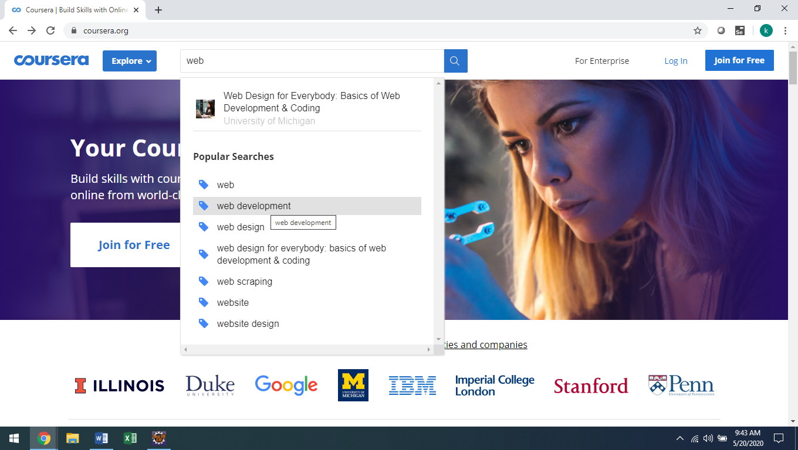

**3.1.1.2 Req0002**

**Req0002a**- The user clicks “Language learning” option under ‘Explore’ menu.

**Req0002b-** The user clicks ‘Levels’ option under list box field.

**Req0002c-** The user clicks ‘Language’ option under listbox field.

**Req0002d-** Click the coursera icon and go back to home page.

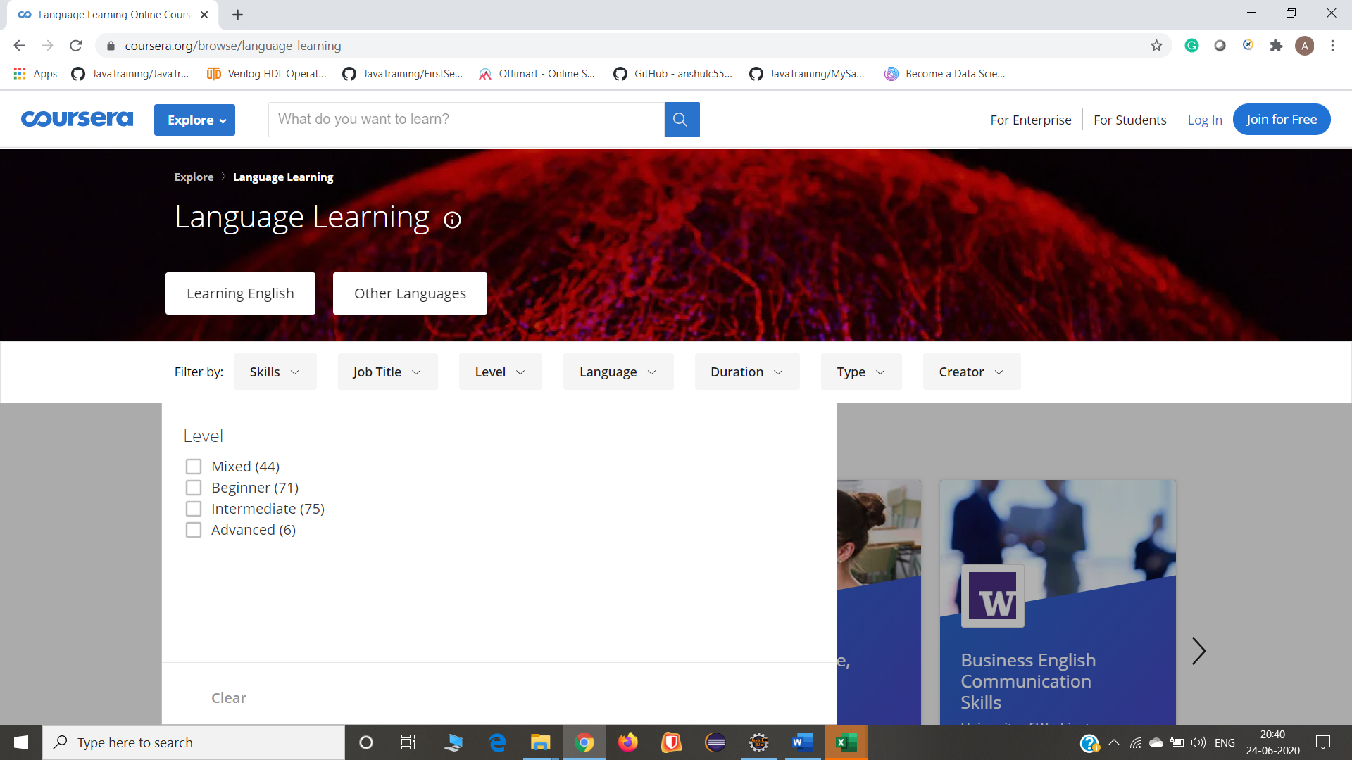

**3.1.2.3 Req0003**

**Req0003a**-click the “For Enterprise button” which will take to page.

**Req0003b-** Click the free demo button

**Req0003c-**It will navigate into the “Transform into talent page” and the form will appear.

**Req0003d-**Leave the any one of the mandatory field and capture the error message.

